7. Implement parallel join and parallel sorting

Parallel Hash Joins in PostgreSQL
When the optimizer determines that parallel query is the fastest execution strategy for a particular query, it will create a query plan that includes a Gather or Gather Merge node. Here is a simple example:
EXPLAIN SELECT * FROM pgbench_accounts WHERE filler LIKE '%x%';

QUERY PLAN
-------------------------------------------------------------------​------------------
Gather (cost=1000.00..217018.43 rows=1 width=97)
Workers Planned: 2
-> Parallel Seq Scan on pgbench_accounts (cost=0.00..216018.33 rows=1 width=97)
Filter: (filler ~~ '%x%'::text)
(4 rows)

In all cases, the Gather or Gather Merge node will have exactly one child plan, which is the portion of the plan that will be executed in parallel. If the Gather or Gather Merge node is at the very top of the plan tree, then the entire query will execute in parallel. If it is somewhere else in the plan tree, then only the portion of the plan below it will run in parallel. In the example above, the query accesses only one table, so there is only one plan node other than the Gather node itself; since that plan node is a child of the Gather node, it will run in parallel.
Using EXPLAIN, you can see the number of workers chosen by the planner. When the Gather node is reached during query execution, the process that is implementing the user's session will request a number of background worker processes equal to the number of workers chosen by the planner. The number of background workers that the planner will consider using is limited to at most max_parallel_workers_per_gather. The total number of background workers that can exist at any one time is limited by both max_worker_processes and max_parallel_workers. Therefore, it is possible for a parallel query to run with fewer workers than planned, or even with no workers at all. The optimal plan may depend on the number of workers that are available, so this can result in poor query performance. If this occurrence is frequent, consider increasing max_worker_processes and max_parallel_workers so that more workers can be run simultaneously or alternatively reducing max_parallel_workers_per_gather so that the planner requests fewer workers.
Every background worker process that is successfully started for a given parallel query will execute the parallel portion of the plan. The leader will also execute that portion of the plan, but it has an additional responsibility: it must also read all of the tuples generated by the workers. When the parallel portion of the plan generates only a small number of tuples, the leader will often behave very much like an additional worker, speeding up query execution. Conversely, when the parallel portion of the plan generates a large number of tuples, the leader may be almost entirely occupied with reading the tuples generated by the workers and performing any further processing steps that are required by plan nodes above the level of the Gather node or Gather Merge node. In such cases, the leader will do very little of the work of executing the parallel portion of the plan.
When the node at the top of the parallel portion of the plan is Gather Merge rather than Gather, it indicates that each process executing the parallel portion of the plan is producing tuples in sorted order, and that the leader is performing an order-preserving merge. In contrast, Gather reads tuples from the workers in whatever order is convenient, destroying any sort order that may have existed.
PostgreSQL 15 introduces a new parallel query feature called “Partitionwise Joins” which can improve the performance of queries involving large tables. Here’s how to implement parallel queries using this feature:
- Ensure that your query involves a join between two or more large tables. Partitionwise joins work best when the tables being joined are partitioned.
- Partition your tables using PostgreSQL’s built-in partitioning feature. Partitioning divides a large table into smaller partitions based on a partition key, which can improve query performance by reducing the amount of data that needs to be scanned.
- Use the SET max_parallel_workers_per_gather configuration parameter to set the maximum number of parallel workers that can be used per parallel gather operation. This parameter limits the number of workers that can be used to execute a query in parallel.
- Use the ENABLE_PARALLEL_HASH configuration parameter to enable parallel hash joins. Parallel hash joins can be faster than traditional hash joins for large tables.
- Use the ENABLE_PARTWISE_JOIN configuration parameter to enable partitionwise joins. Partitionwise joins allow each partition to be joined independently, which can improve parallel query performance.
Here’s an example query that uses partitionwise joins:
SELECT *
FROM orders o
JOIN lineitems l ON o.orderid = l.orderid
WHERE o.orderdate BETWEEN '2022-01-01' AND '2022-12-31'
Assuming that the orders and lineitems tables are partitioned by orderid, you can enable partitionwise joins for this query by adding the following statement:
SET ENABLE_PARTWISE_JOIN=1;

You can also enable parallel hash joins by adding the following statement:
SET ENABLE_PARALLEL_HASH=1;
Finally, you can set the maximum number of parallel workers per gather operation by adding the following statement:
SET max_parallel_workers_per_gather=4;
This statement limits the number of parallel workers to 4, which can improve query performance by limiting the overhead of parallel query execution.
With these configuration settings in place, PostgreSQL will use parallel query execution to improve the performance of the query. Keep in mind that parallel query execution can increase the load on your system, so it’s important to monitor your system resources and adjust the configuration settings as necessary to ensure optimal performance.

Parallel Merge Sort
Merge sort first divides the unsorted list into smallest possible sub-lists, compares it with the adjacent list, and merges it in a sorted order. It implements parallelism very nicely by following the divide and conquer algorithm.
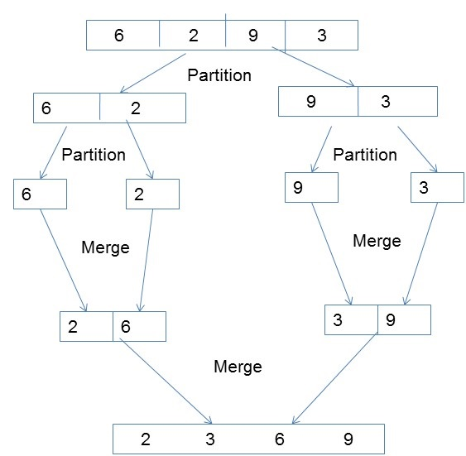

Illustrations:
Consider an array arr[] = { 5, 3, 4, 6, 1, 2, 7, 9, 8};
Follow the below steps to solve the above approach:
- Count the number of elements in each range.
  - For example, in the above array, the number of elements in the range 1 to 3 is 3 (1, 2, 3). The number of elements in the range 3 to 5 is 2 (4, 5). The number of elements in the range 6 to 8 is 3 (6, 7, 8). The number of elements in the range of 9 to 10 is 1 (9).
- Sort the elements in each range according to their frequency.
  - For example, in the above array, the elements in the range 1 to 3 will be sorted in ascending order (1, 2, 3). The elements in the range 3 to 5 will be sorted in ascending order (4, 5). The elements in the range 6 to 8 will be sorted in ascending order (6, 7, 8). The element in the range 9 to 10 will be sorted in ascending order (9).
- Merge the sorted elements in each range.
  - For example, in the above array, the sorted elements in the range 0 to 2 will be merged with the sorted elements in the range 3 to 5 (1, 2, 3, 4, 5). The sorted elements in the range 6 to 8 will be merged with the sorted elements in the range 9 to 10 (6, 7, 8, 9).
- The merged elements are now sorted in ascending order.
- The merged elements will be sorted in ascending order (1, 2, 3, 4, 5, 6, 7, 8, 9).

// Java code for the above approach:
import java.io.*;

class GFG {
// Function to find maximum value in array
public static int getMax(int arr[], int n)
{
int mx = arr[0];
for (int i = 1; i < n; i++)
if (arr[i] > mx)
mx = arr[i];
return mx;
}

// Count sort of arr[]
public static void countSort(int arr[], int n, int exp)
{

// Output array
int output[] = new int[n];
int i;
int count[] = new int[10];

// Store count of occurrences in count[]
for (i = 0; i < n; i++)
count[(arr[i] / exp) % 10]++;

// Change count[i] so that count[i] now contains
// actual position of this digit in output[]
for (i = 1; i < 10; i++)
count[i] += count[i - 1];

// Build the output array
for (i = n - 1; i >= 0; i--) {
output[count[(arr[i] / exp) % 10] - 1] = arr[i];
count[(arr[i] / exp) % 10]--;
}

// Copy the output array to arr[], so that arr[] now
// contains sorted numbers according to current
// digit
for (i = 0; i < n; i++)
arr[i] = output[i];
}

// Parallel count sort
public static void parallelCountSort(int arr[], int n)
{
int m = getMax(arr, n);

// Do counting sort for every digit. Note that
// instead of passing digit number, exp is passed.
// exp is 10^i where i is current digit number
for (int exp = 1; m / exp > 0; exp *= 10) {
for (int i = 0; i < n; i++)
countSort(arr, n, exp);
}
}

// Driver Code
public static void main(String[] args)
{
int arr[] = { 170, 45, 75, 90, 802, 24, 2, 66 };
int n = arr.length;
System.out.print("Array before sorting: \n");
for (int i = 0; i < n; i++) {
System.out.print(arr[i] + " ");
}
System.out.println();
parallelCountSort(arr, n);

System.out.print("Array after sorting: \n");
for (int i = 0; i < n; i++) {
System.out.print(arr[i] + " ");
}
}
}

Output
Array before sorting:
170 45 75 90 802 24 2 66
Array after sorting:
2 24 45 66 75 90 170 802

